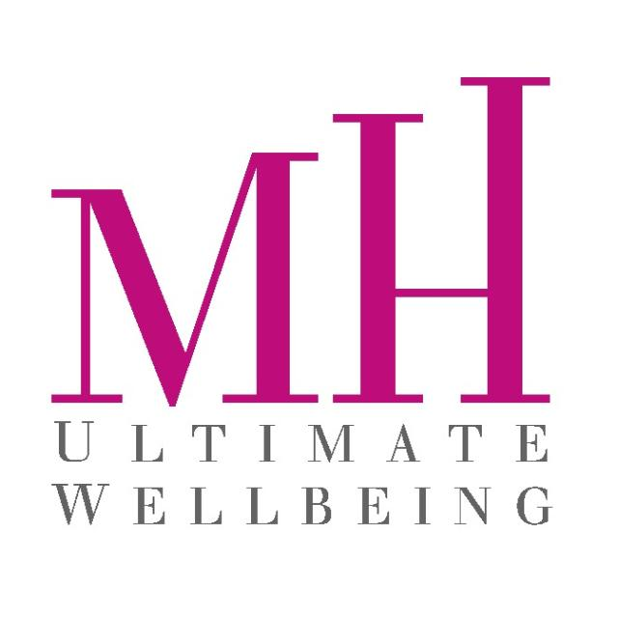

**COUNSELLING CONSENT FORM**

Counselling is a confidential process designed to help you address your concerns, come to a greater understanding of yourself, and learn effective personal and interpersonal skills to help you thrive. It involves a supportive, respectful, and understanding relationship between you and a coach who has the desire and willingness to help you accomplish your individual goals. Counselling involves sharing personal information; this process may sometimes be distressing. In the course of counselling, there may be periods of increased anxiety or confusion. The outcome of counselling is often positive; however, the level of satisfaction for any individual is not predictable. During your initial session, you and your coach will determine an action plan which may include one or more of the following options: self-directed goal, online assisted therapy, workshops, exercises, intensive short-term individual therapy, or referrals to other services. Please feel free to discuss with your coach any questions that you may have about the counselling process.

**CANCELLATION POLICY**

If you need to cancel or reschedule an appointment (including workshop and sessions), please advise MH Ultimate Wellbeing – Counselling & Coaching at least 24 hours in advance. All appointments cancelled or missed with less than 24 hours’ notice are subject to a 50% re-booking fee. No shows or same day cancellations – 100% of treatment costs. Please cancel on Friday for appointments on Monday. I have read the above information. I understand the risks and benefits of counselling and I agree to take part in the counselling process. I understand that I can withdraw my consent at any time.

**INFORMATION ABOUT CONFIDENTIALITY MH ULTIMATE WELLBEING**

Counselling & Coaching has several services available to you. These services include counselling - NLP and personal/ business coach, online supported therapy, personal development workshops, peer to peer support, group counselling, and other specialized programs. All interactions with MH Ultimate Wellbeing, including the scheduling of your appointments, your attendance at appointments, the content of your sessions, your progress in counselling, and your records, are confidential.

**MH Ultimate Wellbeing – Counselling & Coaching EXCEPTIONS TO CONFIDENTIALITY**

Furthermore, disclosure may be required in any of the following circumstances:

* If the client poses a danger to themselves or others
* If the therapist suspects the abuse of a child or an elderly or otherwise dependent adult
* If they are legally forced to by court order

If we are concerned about you or if you fail to show for a scheduled appointment, we will contact you to check on your well-being. If I show signs of deterioration that indicate I may be in danger, I grant MH Ultimate Wellbeing Counselling & Coaching and my therapist permission to contact me. Initial If I fail to respond to a check-in or if I show indicators that I may be at serious risk for self-harm or harm to others, I understand that MH Ultimate Wellbeing – Counselling & Coaching is required to contact my emergency contact or a crisis response service to ensure my safety and well-being.

**COUNSELLING RECORD**

Counselling records are stored electronically in a secure server-based internal systems called FRESHA APP, ZOOM MEETING and GOOGLE MEETINGS. Its components, including counselling files, are managed and accessible by select staff within MH Ultimate Wellbeing Information Technology team. Paper records are securely kept in the Michelle Hadad the owner of MH Ultimate Wellbeing – Counselling & Coaching unit. Although your counselling record remains, you have the right to access the personal information we hold concerning you by submitting a written request. You may also request with written consent that MH Ultimate Wellbeing – Counselling and Coaching release specific information about your counselling to individuals of your choice. Client files are kept for six (6) months before they are securely destroyed. I agree to MH Ultimate Wellbeing – Counselling & Coaching collecting, using, and disclosing personal information about me as set out above. I understand and acknowledge the limitations concerning confidentiality and accept those limitations. Initial I understand the purpose, expectations, possible benefits, risks, emergency procedures, cancellation policy, and confidentiality policies of the MH Ultimate Wellbeing – Counselling & Coaching. I consent to participate in the counselling process.

Client Signature: ___________________ Date:______________________

Therapist Signature: ___________________ Date:______________________